SAKSHAM SHARMA

B. Tech - Electronics and Communication Engineering (ECE)

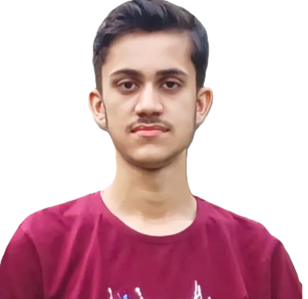

Roll number:22EC8067

Gender: Male

Date of Birth: 08/09/2004

Category: OP

E-mail: [sakshamsharma9737@gmail.com](mailto:sakshamsharma9737@gmail.com)

Contact: [LinkedIn](https://www.linkedin.com/in/saksham-sharma-bb8a3a2a8/), [Github](https://github.com/SakshamSharma10989)

Address: Jammu, J&K

**Educational Qualification**

* **Graduation**

|  |  |  |  |  |  |  |
| --- | --- | --- | --- | --- | --- | --- |
| **SEM** | **1** | **2** | **3** | **4** | **5** | **6** |
| **SGPA** | **6.82** | **7.59** | **9.43** | **7.52** | **8.91** | **8.21** |
| **CGPA** | **6.82** | **7.17** | **7.93** | **7.82** | **8.04** | **8.07** |

* **Higher Secondary & Secondary**

|  |  |  |  |
| --- | --- | --- | --- |
| **Year** | **Degree/Examination** | **Institution/Board** | **CGPA/Percentage** |
| 2022 | Class XII | Central Board of Secondary Education | 89.6% |
| 2020 | Class X | Central Board of Secondary Education | 90.3% |

# Skills Summary

* Technical Skills : React.js, JavaScript, Node.js, MongoDB, HTML, CSS, MySQL, Next.js.
* Non-Technical Skills : Problem Solving, Teamwork, Adaptability, Flexibility, Time Management.

## Projects

* **ChatWave** [**Github**](https://github.com/SakshamSharma10989/ChatApp)

❖**Developed a Real-Time Messaging Application:** Utilized React and Socket.IO to create a chat app enabling instant message exchange, ensuring seamless communication between users.

❖**Implemented Secure User Authentication:** Integrated JWT for secure user authentication, ensuring data privacy and secure user sessions.

* **RecipeApp**  [**Github**](https://github.com/SakshamSharma10989/FoodRecipeApp)

❖**Developed a Feature-Rich Recipe Application:** Allows users to search, save, and manage recipes efficiently.

❖**Integrated External APIs:** Leveraged APIs to provide a diverse recipe database, ensuring have access to a wide range of culinary options**.**

# Achievements

❖Solved more than 300 leetcode problems.

❖2 star coder at [codechef](https://www.codechef.com/users/saksham989).